Task 1
A)
Before the analysis, we reverse-coded three items (hmsfmlsh, rlgatnd and pray) so that, within each concept, a higher score indicates more of the concept it measures. The three items on gays and lesbians therefore measure a negative attitude towards gays and lesbians. We then checked the 16 items for missing values: none were found, so all 30 countries were retained. Then, we standardised the data because the items were measured on different scales (0–10, 1–5, 1–7 and 0–6). It follows that the total variance of the data is 16.
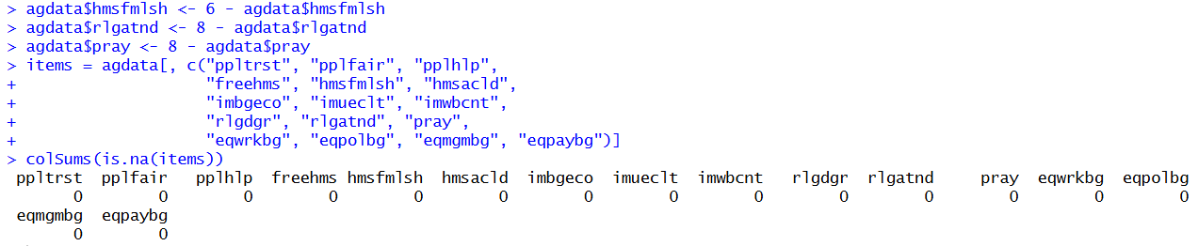
Next, we performed a principal component analysis, which can be interpreted as the eigendecomposition of the correlation matrix, and obtained the eigenvalues, the proportion of variance explained by each component and the cumulative proportion of explained variance. The first component has a very large eigenvalue (10.66) and explains approximately 67% of the total variance in the data. The second and third components have eigenvalues of 2.26 and 1.28 and explain 14% and 8% of the variance, respectively. From the fourth component onward, the eigenvalues are below 1 (0.70 and smaller). The first two components together explain 81% of the variance.
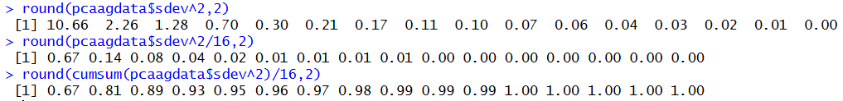
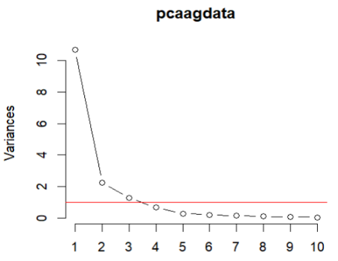

We then constructed a scree plot to determine how many principal components to retain. The scree plot shows an elbow at the second component, which suggests retaining one, or possibly two, components. Using Kaiser’s rule, which retains the components with an eigenvalue greater than 1, three components should be retained. After the third component, the eigenvalues drop below 1, indicating that the subsequent components explain less variance than a single standardised variable.
Horn’s procedure, however, is a better method for determining the number of components to retain, because it retains only components that capture more than chance variation. We applied Horn’s procedure, using both the mean of the bootstrapped eigenvalues and the more conservative 95th percentile. With the mean criterion, the observed eigenvalues exceed the mean random eigenvalues only for the first two components: their adjusted eigenvalues (9.13 and 1.12) are greater than 1, so two components should be retained. The adjusted eigenvalue of the second component, however, is only just above 1. With the 95th percentile criterion, only the first component has an adjusted eigenvalue greater than 1 (8.77), so only one component should be retained. In the remainder of this exercise, we therefore present both the one-component and the two-component solutions.
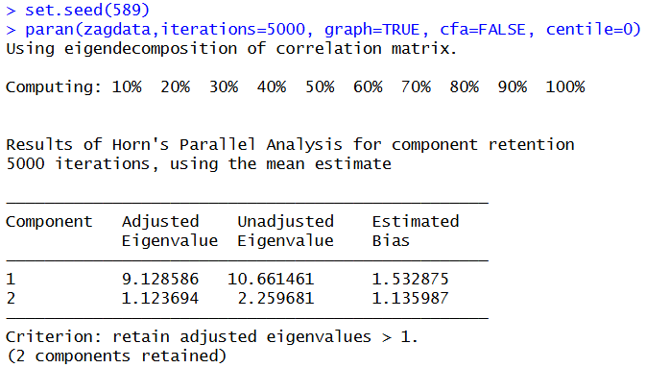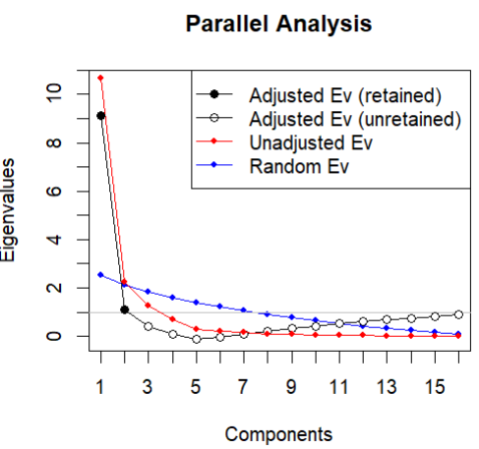
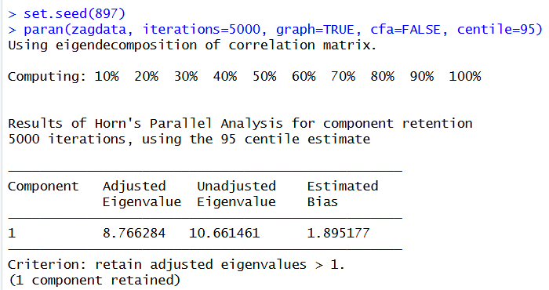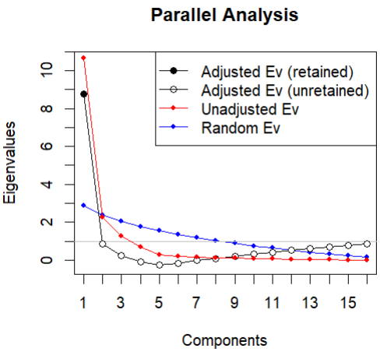
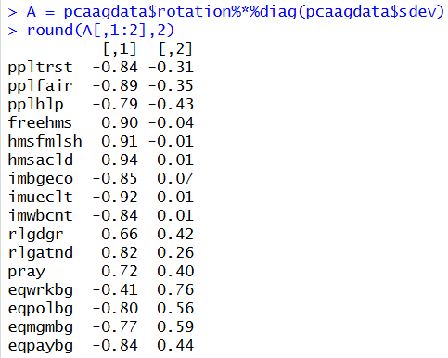
Next, we computed the component loadings to interpret the principal components. Because the variables are standardised, the loadings are the correlations between the items and the components. PC1 is a general dimension on which 15 of the 16 items load substantially; only eqwrkbg has a weaker loading (−0.41). The social trust, positive attitude towards immigrants and positive attitude towards gender equality items load negatively, whereas the negative attitude towards gays/lesbians and religiousness items load positively. The strongest loadings are those of hmsacld (0.94), imueclt (−0.92) and hmsfmlsh (0.91). A high score on PC1 therefore indicates lower social trust, a less positive attitude towards immigrants and gender equality, a more negative attitude towards gays/lesbians and higher religiousness; a low score indicates the opposite. On PC2, the positive attitude towards gender equality items load positively (0.44 to 0.76), the religiousness items moderately positively (0.26 to 0.42) and the social trust items negatively (−0.31 to −0.43), while the gays/lesbians and immigrants items hardly load on PC2 (−0.04 to 0.07). A high score on PC2 therefore indicates a more positive attitude towards gender equality, somewhat higher religiousness and lower social trust; a low score indicates the opposite.

Finally, we calculated the proportion of variance accounted for (VAF) in each variable by the first component and by the first two components. These results support retaining two principal components. With one component, the VAF is low for eqwrkbg (0.17) and for the religious items rlgdgr (0.44) and pray (0.52). These low values disappear when two components are included.
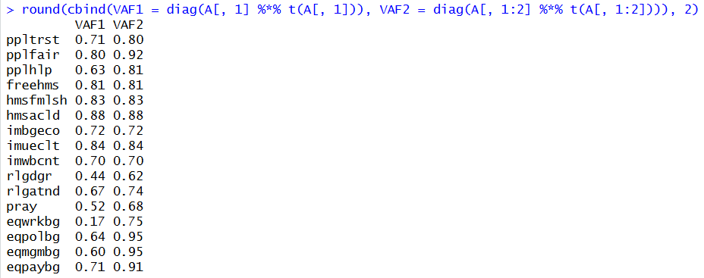
In conclusion, it is best to retain two components, which together explain 81% of the variance. This choice is supported by Horn’s mean criterion and the VAF per item, but we should take into account that the 95th percentile criterion reminds us that PC2 is borderline.

B)
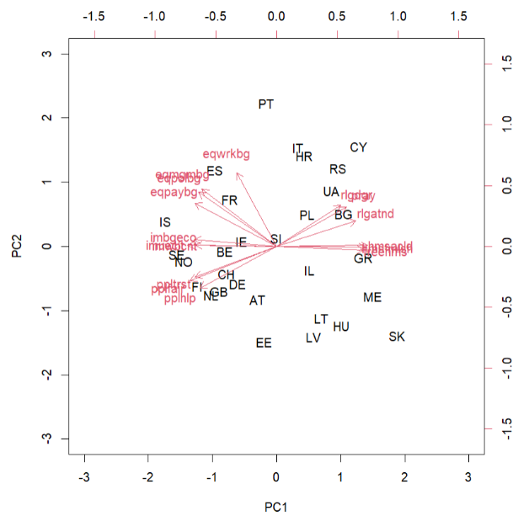
The biplot represents the 30 countries by their standardised component scores and the 16 items by their component loadings on the first two principal components. Countries that lie close together have similar scores on PC1 and PC2. The biplot does not give a perfect representation of the data, because it only takes the first two principal components into account, which together explain 81% of the variance. Although the approximation is not perfect, it is fairly close.
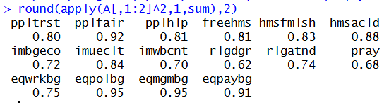
The squared length of each vector in the biplot represents the proportion of that variable’s variance accounted for by the first two principal components. All gender-equality items are well represented, with eqpolbg and eqmgmbg having the longest vector and thus the largest proportion of variance accounted for (0.95). At the other end, rlgdgr has the shortest vector and the smallest proportion of variance accounted for (0.62). However, even the smallest values are relatively large, so the plot can be interpreted for every item.
The angles between the vectors demonstrate the predicted correlations between the items. Items that measure the same concept point in roughly the same direction, so they are positively correlated with each other; the strongest correlation is between eqpolbg and eqmgmbg (0.95). The social trust, attitude immigrants and attitude gender equality items all point to the left, whereas the items measuring a negative attitude towards gays and lesbians point to the right, close to the religiousness items. The gays/lesbians items therefore point nearly opposite to the immigration and trust items, which gives the most negative predicted correlations (down to −0.86 for imueclt and hmsacld): countries with more positive attitudes towards immigrants and more social trust tend to have less negative attitudes towards gays and lesbians. Likewise, the religiousness items point nearly opposite to the trust items (down to −0.83 for pplfair and rlgatnd). The gender-equality items are moderately positively correlated with the trust items (0.36 to 0.60) and negatively correlated with the religiousness items (−0.26 to −0.57). The exception is eqwrkbg: its vector is almost perpendicular to the trust and religiousness items, so how positive a country is about women in paid work is nearly unrelated to its level of social trust or religiousness.
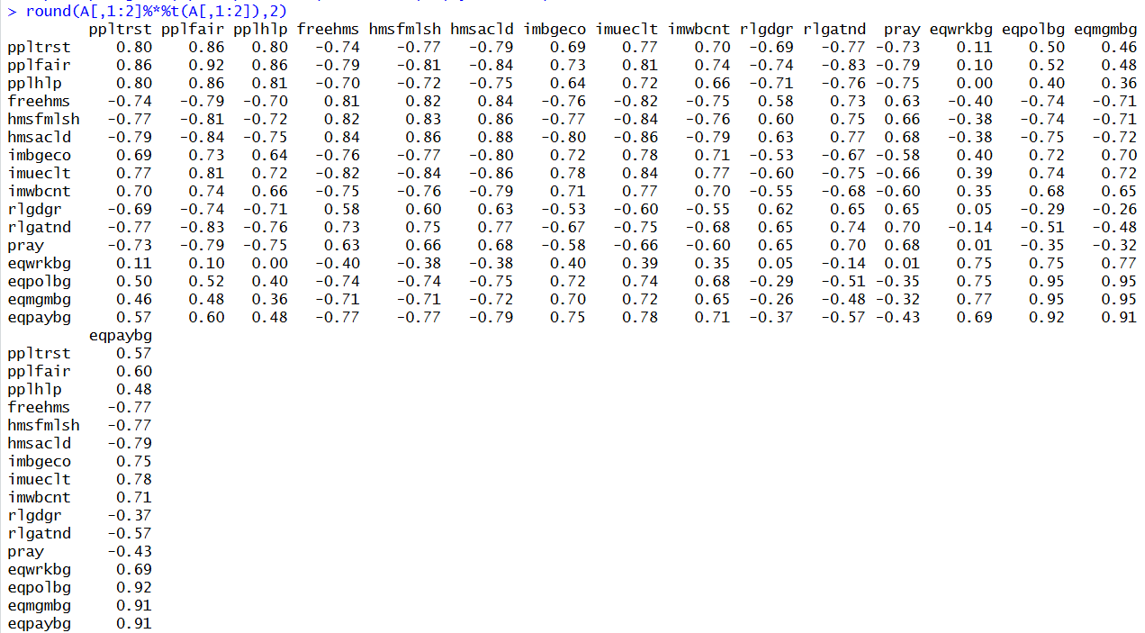
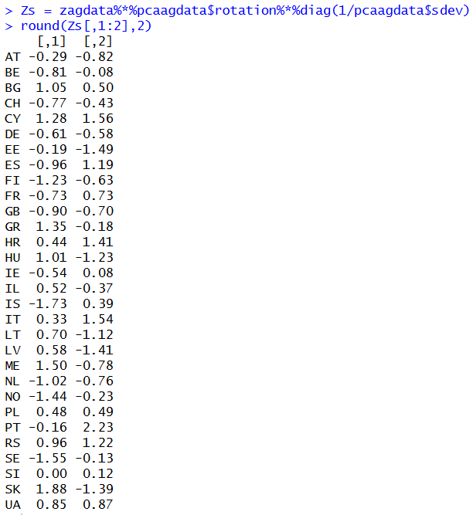
Finally, we computed the standardised component scores to determine which countries score high and low on each principal component. On PC1, the Nordic countries (IS, SE, NO, FI) and the Western European countries (BE, NL, GB, CH, DE, IE) lie towards the left, in the direction of the social trust, gender-equality and immigration vectors and away from the vectors of negative attitudes towards gays and lesbians and religiousness. SK, ME, GR, CY, BG, HU and RS lie towards the right, with the opposite characteristics. On PC2, Portugal (PT) has the highest score and lies in the direction of the gender-equality vectors (especially eqwrkbg), whereas Estonia (EE) has the lowest score. More generally, the Southern European countries (PT, IT, HR, ES) score high on PC2 and the Baltic and Central European countries (EE, LV, LT, HU) score low. Relative to their position on PC1, the former are more positive about gender equality, more religious and less trusting, whereas the latter are less positive about gender equality, less religious and more trusting.

